## INTERNSHIP REPORT

***Submitted by***

## KINGSLIN.P (950421104026)

***In partial fulfillment for the award of the degree***

***Of***

**BACHELOR OF ENGINEERING**

### IN

**COMPUTER SCIENCE AND ENGINEERING**



**DR.G.U.POPE COLLEGE OF ENGINEERING, THOOTHUKUDI-628251**

**ANNA UNIVERSITY: CHENNAI 600 025**

**NOVEMBER 2024**

**CERTIFICATION**

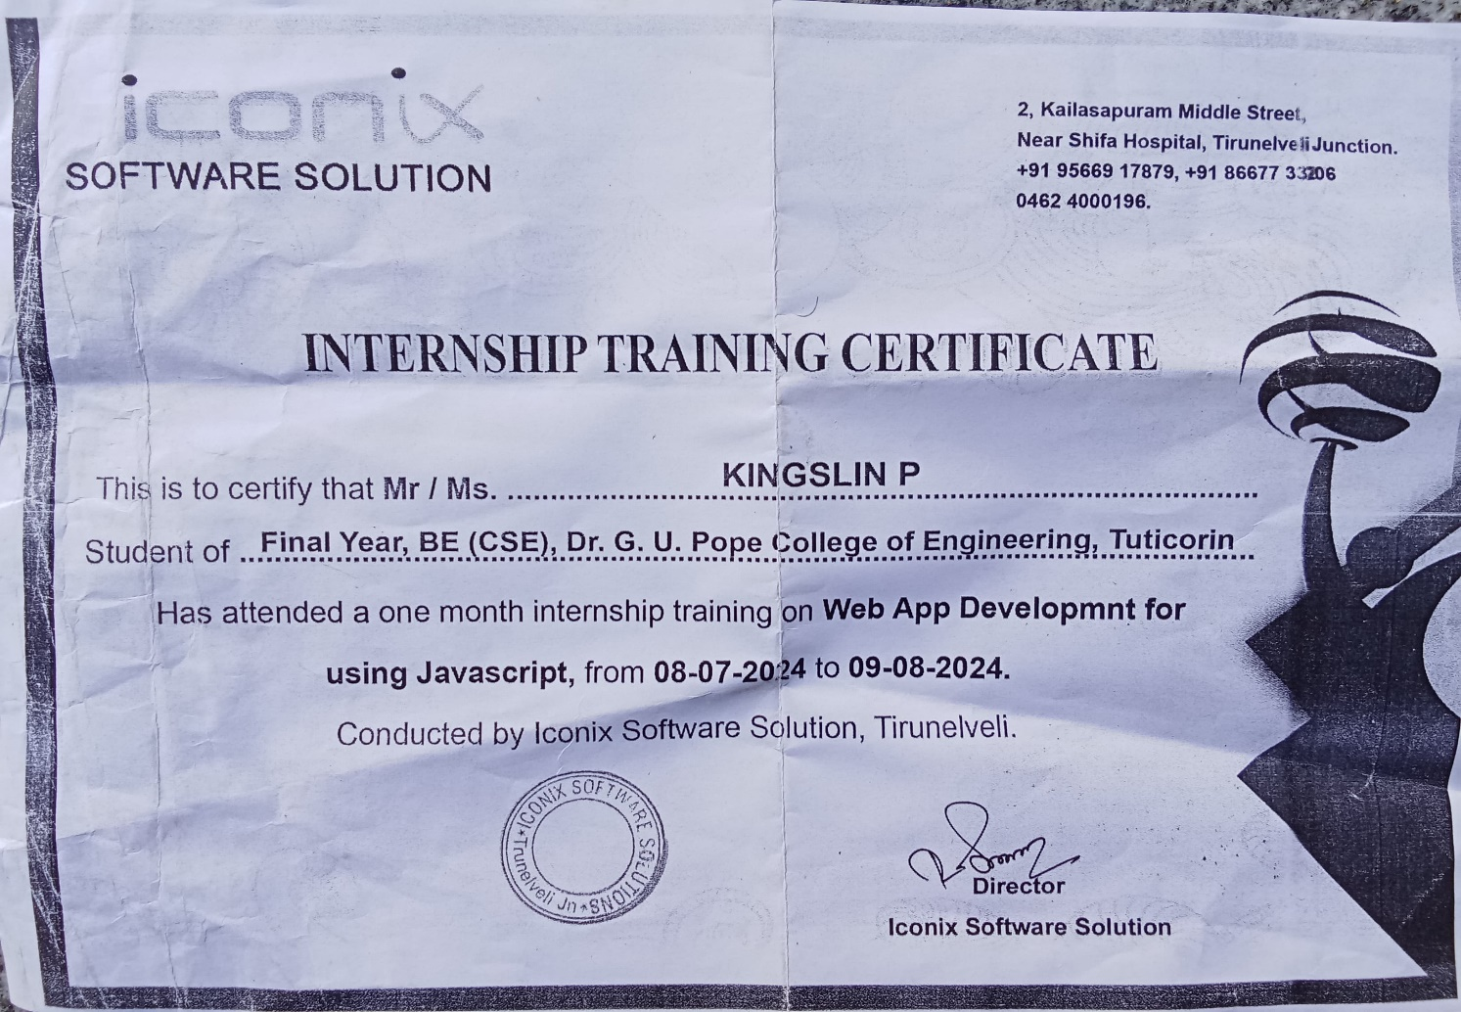

### ABSTRACT

### Project Title: Encryption/Decryption with Caesar Cipher: A Web-based Implementation

### The project focuses on implementing a web-based encryption and decryption tool using the Caesar Cipher technique, a classical cipher used for securing messages. The tool provides a simple and user-friendly interface, developed using HTML, CSS, and JavaScript, to demonstrate how data can be securely encoded and decoded through letter shifting.

### The Caesar Cipher works by shifting each letter of the plaintext by a certain number (key) along the alphabet. The encryption process transforms the original message into an unreadable format, while the decryption process restores it to its original form. This project allows users to input a message, apply the cipher to encode it, and later decode it using the same key.

### The user interface is designed with HTML for the structure, CSS for styling, and JavaScript for the logic behind the cipher functions. The project also includes a visual output to display the encrypted or decrypted message in real-time. The Caesar Cipher's key can be adjusted, enabling users to experiment with different shift values to observe how the encoded data changes.

### This tool provides an educational introduction to basic encryption concepts and can serve as a starting point for more complex cryptographic systems. It highlights the importance of cryptography in data security and demonstrates the fundamentals of secure communication.

### Keywords: Caesar Cipher, Encryption, Decryption, Web Application, Data Security, JavaScript, HTML, CSS

## Problem Statement

**In the digital age, data security is essential to protect sensitive information from unauthorized access. One fundamental technique for securing information is encryption, where data is transformed into a non-readable format and can only be reverted to its original form with the correct decryption key. The Caesar Cipher, one of the oldest and simplest encryption algorithms, shifts letters of the plaintext by a specified number along the alphabet.**

**The goal of this project is to create a web-based tool that allows users to encrypt and decrypt messages using the Caesar Cipher algorithm. The tool should have the following capabilities:**

1. **Encryption: Given a plaintext message and a shift value (key), the tool should encrypt the message by shifting each letter in the plaintext by the given value.**
2. **Decryption: The tool should allow users to decrypt a given encrypted message by reversing the shift based on the key provided.**
3. **User Input and Interaction: The tool should take user input for both the plaintext and the key (shift value). Users should be able to interact with the tool through a simple interface and view the results in real-time.**
4. **Simple Interface: The web tool should be designed using HTML, CSS, and JavaScript to ensure a smooth and intuitive user experience. It should display clear instructions for entering text and shifting values.**
5. **Real-Time Display: The encrypted or decrypted message should be displayed dynamically as the user interacts with the input fields.**

**The main challenge of the project lies in implementing the Caesar Cipher algorithm correctly, ensuring accurate encoding and decoding operations. Additionally, the tool should be able to handle both upper and lower case letters, special characters, and spaces without causing errors or misinterpretation.**

**This project will help demonstrate the basic principles of encryption and decryption while providing a hands-on tool for learning how the Caesar Cipher works. It also serves as an introductory exercise in cryptography, web development, and secure data handling.**

**Scope:**

* **The project will be developed using standard web technologies: HTML for the structure, CSS for the presentation, and JavaScript for the functionality.**
* **The tool will work with alphabetic text only, handling both uppercase and lowercase letters. Special characters and spaces will be ignored or preserved in the output.**
* **The tool will support a variable shift value, allowing users to experiment with different levels of encryption strength.**

**Deliverables:**

* **A fully functional web-based encryption and decryption tool.**
* **A user-friendly interface for inputting messages and shift values.**
* **An implementation of the Caesar Cipher that can encrypt and decrypt text.**
* **A final report documenting the development process, challenges, and lessons learned.**

**LIST OF FIGURES**

|  |  |  |
| --- | --- | --- |
| **FIGURE NO** | **TITLE** | **PAGE NO** |
| 4.1 | Caesar Cipher in Cryptography | 6 |
| 4.2 | Flowchart of Processing | 8 |
| 6.1 | The project directory | 16 |
| 6.2 | The project contain files | 17 |
| 6.3 | Browser used to run and output displayed | 17 |
| 6.4 | Encode button used given input | 18 |
| 6.5 | After created the encryption data | 18 |
| 6.6 | Given encryption data, click decode button | 19 |
| 6.7 | After showing the plain text | 19 |

**TABLE OF CONTENTS**

|  |  |  |
| --- | --- | --- |
| **CHAPTER**  **NO** | **TITLE** | **PAGE**  **NO** |
| **1** | **INTRODUCTION** | **1** |
|  | 1.1 Domain Introduction | 2 |
| **2** | **OBJECTIVES** | **3** |
| **3** | LITERATURE REVIEW | **4** |
|  | 3.1 Future potential research direction | 5 |
| **4** | **SYSTEM DESIGN** | **6** |
|  | 4.1 Architecture | 6 |
|  | 4.2 Components | 7 |
|  | 4.3 Hardware Requirements | 9 |
|  | 4.4 Technical software Requirements | 9 |

|  |  |  |
| --- | --- | --- |
| **5** | **IMPLEMENTATION** | **10** |
|  | 5.1 Frontend Development | 10 |
|  | 5.2 JavaScript Logic | 10 |
|  | 5.3 Testing the Tool | 11 |
|  | 5.4 Deployment | 11 |
|  | 5.5 Source code | 12 |
| **6** | **TESTING AND EVALUATION** | **16** |
|  | 6.1 Web application Testing : (screenshots) | 16 |
|  | 6.2 Types of Testing | 20 |
|  | 6.3 Evaluation Criteria | 21 |
| **7** | **CONCLUSION** | **22** |
|  | 7.1 Key Achievements | 22 |
|  | 7.2 Future Directions | 23 |
| **8.** | **REFERENCES** | 24 |

CHAPTER 1

INTRODUCTION

In today's interconnected world, ensuring the confidentiality of sensitive information is crucial. Data security relies heavily on encryption, a process that transforms readable information into an unreadable format to prevent unauthorized access. Decryption, on the other hand, restores the encrypted data to its original state using a specific key. Among the earliest encryption techniques is the Caesar Cipher, a simple yet effective algorithm named after Julius Caesar, who used it for secure communication during his military campaigns.

The Caesar Cipher operates by shifting each letter of the alphabet by a fixed number of positions, determined by a key. For example, with a shift of 3, the letter 'A' becomes 'D', and 'B' becomes 'E'. While basic, this technique introduces the core principles of cryptography and demonstrates the transformation of data for secure transmission.

This project focuses on developing a web-based encryption and decryption tool using the Caesar Cipher. Built with HTML, CSS, and JavaScript, the tool provides a simple and interactive interface for users to encode and decode messages. Users can input a plaintext message and a shift value (key) to generate the encrypted text, which can then be decrypted back to its original form using the same key.

The tool emphasizes both functionality and user experience, ensuring ease of use while demonstrating the Caesar Cipher's mechanics. It allows users to experiment with different shift values, making it an educational resource for understanding the basics of cryptography. Although the Caesar Cipher is no longer used for secure communications due to its simplicity, its importance in the history of cryptography cannot be overstated.

By bridging theory and practice, this project highlights the role of encryption in securing data and provides an engaging way to learn about cryptographic algorithms.

* 1. domain INTRODUCTION :

**Cryptography and Data Security :** In the digital era, securing sensitive information has become a critical concern as data travels across networks susceptible to unauthorized access and cyber threats. Cryptography, the science of protecting information through encoding techniques, ensures confidentiality, integrity, and authenticity in communication. By converting readable data (plaintext) into an unreadable format (ciphertext), cryptography prevents unauthorized entities from accessing sensitive information. Only those with the proper decryption keys can revert the ciphertext back to plaintext, making cryptography essential for secure communication.

Historically, cryptography began with simple techniques like the **Caesar Cipher**, a method used by Julius Caesar to protect military communications. This cipher operates by shifting letters in the alphabet by a specific number of positions, offering a foundational understanding of encryption. While primitive by modern standards, the Caesar Cipher is significant as it introduces basic concepts of secure data transformation.

Today, cryptography is a cornerstone of cybersecurity, ensuring the safety of online transactions, communications, and sensitive data storage. Advanced cryptographic algorithms are now used in technologies like Secure Socket Layer (SSL), blockchain, and end-to-end encryption for messaging applications. These systems safeguard personal, financial, and organizational information from malicious attacks.

CHAPTER 2

OBJECTIVES

The primary objective of this project is to develop a web-based tool for encryption and decryption using the Caesar Cipher algorithm. This tool aims to provide an interactive platform for understanding the fundamental principles of cryptography, emphasizing secure communication and data protection.

The specific objectives include:

* **Implement Encryption:** Create a functionality that allows users to encode plaintext messages into ciphertext using the Caesar Cipher algorithm, based on a user-defined shift value (key).
* **Implement Decryption:** Provide a decryption feature that reverses the encryption process, restoring the ciphertext to its original plaintext using the same shift value.
* **Interactive Interface:** Design a user-friendly web interface with HTML, CSS, and JavaScript, allowing users to input text, specify the shift value, and view results in real-time.
* **Educational Purpose:** Offer an accessible way for users to experiment with and understand the mechanics of the Caesar Cipher, fostering knowledge of basic cryptographic principles.
* **Preserve Non-Alphabetic Characters:** Ensure that spaces, special characters, and numbers are preserved during the encryption and decryption processes to maintain message readability.
* **Dynamic Display:** Provide instant visual feedback of encrypted or decrypted messages to enhance usability and interactivity.
* **Promote Cryptographic Awareness:** Demonstrate the importance of encryption and its applications in securing communication, inspiring further exploration into advanced cryptographic techniques.

### CHAPTER 3

### LITERATURE REVIEW

Cryptography has played a significant role in secure communication throughout history, evolving from simple manual techniques to complex algorithms used in modern digital systems. One of the earliest encryption methods, the **Caesar Cipher**, was developed by Julius Caesar to securely transmit military messages. This cipher employs a substitution technique where letters in the plaintext are shifted by a fixed number of positions in the alphabet. While simplistic, the Caesar Cipher is foundational in understanding the principles of cryptographic transformation and key-based encoding systems.

The **Caesar Cipher** is a monoalphabetic substitution cipher, which means a single mapping of plaintext to ciphertext is used throughout the encryption process. Despite its historical significance, the cipher is vulnerable to brute-force attacks due to its limited keyspace (26 possible shifts for the English alphabet). This vulnerability underscores the importance of evolving cryptographic techniques to address security limitations.

Modern cryptography builds upon these foundational ideas, introducing algorithms such as Advanced Encryption Standard (AES), Rivest–Shamir–Adleman (RSA), and Elliptic Curve Cryptography (ECC). These methods use more complex mathematical operations and larger keyspaces to ensure secure communication. Studies on cryptographic algorithms highlight the balance between computational efficiency and security strength, emphasizing the importance of selecting algorithms based on the application's requirements.

Literature on educational cryptographic tools suggests that hands-on experimentation helps in understanding basic principles, such as encryption and decryption processes. Interactive platforms, including web-based applications, are effective in demonstrating concepts like substitution and key-based encryption. The Caesar Cipher, being intuitive and easy to implement, is often used in introductory lessons on cryptography.

The implementation of the Caesar Cipher in web development using **HTML**, **CSS**, and **JavaScript** aligns with these educational objectives. Research shows that visual and real-time feedback enhances user engagement and comprehension. Tools developed with a focus on usability can serve as a stepping stone for learners to explore advanced topics in data security and cryptographic algorithms.

This literature review demonstrates the relevance of the Caesar Cipher as a pedagogical tool for understanding cryptography's evolution and basic principles. The proposed project leverages these insights to create an accessible and interactive encryption/decryption platform, bridging the gap between theory and practical application.

**Future Potential Research Directions**

* Exploration of Modern Cryptographic Algorithms:
* Dynamic Key Management Systems:
* Strengthening Against Cryptanalysis:
* User Authentication Mechanisms:
* Data Privacy in Machine Learning:
* Blockchain and Decentralized Systems:

### ****CHAPTER 4****

### ****SYSTEM DESIGN****

The system design for this project outlines the architecture, components, and flow of the encryption and decryption tool. The system is built using a web-based architecture with HTML, CSS, and JavaScript for the front-end and logic implementation.

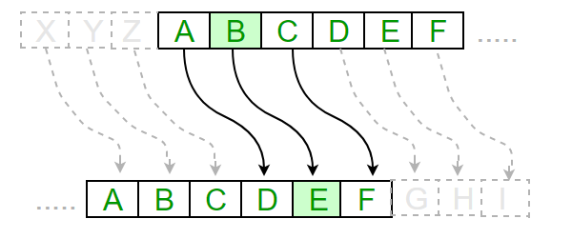

**Figure – 4.1 Caesar Cipher in Cryptography**

**Architecture**

The system adopts a client-side architecture since all operations (encryption and decryption) are performed locally within the user's browser. This ensures simplicity, eliminates the need for server-side processing, and enhances user privacy by keeping data on the client device.

**Components**

* **User Interface (UI):**

Input Field: Textarea for users to input the plaintext or ciphertext.

Shift Key Input: A numeric field for users to specify the shift value (key).

Buttons: Interactive buttons for performing encryption or decryption.

Output Display: A section to show the encrypted or decrypted message.

* **Processing Logic:**

Encryption Function: Implements the Caesar Cipher by shifting characters in the plaintext forward based on the provided key.

Decryption Function: Reverses the Caesar Cipher by shifting characters in the ciphertext backward based on the same key.

Character Handling: Ensures case sensitivity and retains non-alphabetic characters (spaces, symbols, etc.) in the output.

* **Styling (CSS):**

Provides a visually appealing interface with responsive design for seamless usability on various devices.

* **Dynamic Behavior (JavaScript):**

Handles user interactions, executes the encryption and decryption logic, and dynamically updates the output in real time.

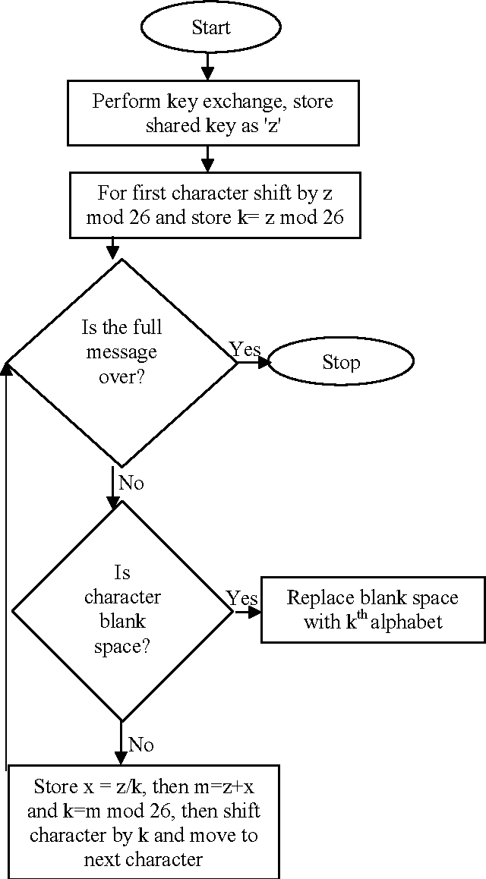

**Figure – 4.2 Flowchart of Processing**

**Hardware Requirements:**

* **Processor:** Intel Core i3 or equivalent
* **RAM:** 2GB or more
* **Storage:** 50GB or more HDD/SSD
* **Operating System:** Windows 10/11, macOS, or Linux (Ubuntu, Debian)
* **Network Connectivity:** Stable internet connection for updates

**Technical Software Requirements**

* **Operating System: Platform-independent (runs on any OS with a web browser).**
* **Browser Support: Latest versions of Google Chrome, Mozilla Firefox, Microsoft Edge, Safari.**

**Programming Languages:**

* **HTML: For structuring the web interface.**
* **CSS: For styling and responsive design.**
* **JavaScript: For encryption, decryption logic, and interactivity.**

**CHAPTER 5**

**IMPLEMENTATION**

The implementation of this project involves structuring the system in three main components: HTML, CSS, and JavaScript. Here's a step-by-step explanation of the development process

#### 1. Frontend Development

##### **1.1. HTML Structure**

* Use HTML to create the structure of the web interface.
* The interface includes:
  + Text Input Area: For users to enter the plaintext or ciphertext.
  + Numeric Input Field: To specify the shift key.
  + Buttons: For encryption and decryption operations.
  + Output Section: To display the results.

##### **1.2. CSS Styling**

* Use **CSS** for styling the interface to make it visually appealing and responsive.

#### 2. JavaScript Logic

* Use **JavaScript** to implement the Caesar Cipher encryption and decryption functionality.

##### **2.1. Encryption Function**

* Loop through each character of the input text.
* Shift alphabetic characters forward by the shift key value.
* Keep non-alphabetic characters unchanged.

##### **2.2. Decryption Function**

* Loop through each character of the input text.
* Shift alphabetic characters backward by the shift key value.
* Maintain non-alphabetic characters as is.

#### 3. Testing the Tool

* Test the application locally using a **Live Server** or by opening the HTML file in a web browser.
* Verify the functionality by entering text, specifying a shift key, and clicking the **Encrypt** and **Decrypt** buttons.
* Ensure edge cases are handled, such as:
  + Non-alphabetic characters.
  + Negative or large shift values.

#### 4. Deployment

* Deploy the tool on platforms like **GitHub Pages**, **Netlify**, or **Vercel** for easy sharing and access.
* Share the project link for demonstration and feedback.

This implementation provides a complete, functional tool to demonstrate the Caesar Cipher, showcasing encryption and decryption principles in a user-friendly manner.

* 1. **SOURCE CODE:**

**HTML :**

<!DOCTYPE html>

<html lang="en">

<head>

<meta charset="UTF-8">

<meta name="viewport" content="width=device-width, initial-scale=1.0">

<title>Encryption</title>

<link rel="stylesheet" href="style.css">

<script src="script.js"></script>

</head>

<body>

<h1> Insternship project</h1>

<p class="center">

A Encryption / Decryption project with Caesar Cipher in action.

</p>

<div style="padding:30px;background:#f3f3f3;border:solid 5px; border-radius:10px;width:60%;margin:auto">

<textarea id="txtMessage" class="form-control" placeholder="Enter your message"></textarea>

<div style="margin-top: 10px;">

<a href="javascript:void(0)" onclick="encode()" class="btn">Encode</a>

<a href="javascript:void(0)" onclick="decode()" class="btn" style="margin-left: 10px;">Decode</a>

</div>

<div style="margin-top: 20px;">

<strong>Output</strong>

<div id="cipher" style="padding: 10px; background: #fff; border: solid 1px #ccc; border-radius: 5px;"></div>

</div>

</div>

</body>

</html>

**CSS:**

h1{

font-size: 40pt;

font-family: sans-serif;

text-align: center;

}

.center{

text-align: center;

}

textarea{

width: 90%;

padding: 20px;

border:solid 1px #ddd;

}

.btn{

background: dodgerblue;

color: white;

padding: 10px 20px;

text-decoration: none;

display: inline-block;

}

**JAVASCRIPT:**

var alphabet = "abcdefghijklmnopqrstuvwxyz";

var newalphabet = "";

// Create a shifted alphabet

function createShift(n) {

for (let i = 0; i < alphabet.length; i++) {

let offset = (i + n) % alphabet.length;

newalphabet += alphabet[offset];

}

}

// Encode the message

function encode() {

let message = document.getElementById('txtMessage').value;

let result = "";

message = message.toLowerCase();

for (let i = 0; i < message.length; i++) {

let index = alphabet.indexOf(message[i]);

if (index > -1)

result += newalphabet[index];

else

result += ' ';

}

document.getElementById('cipher').innerHTML = result;

return result;

}

// Decode the message

function decode() {

let encodedMessage = document.getElementById('txtMessage').value;

let result = "";

encodedMessage = encodedMessage.toLowerCase();

for (let i = 0; i < encodedMessage.length; i++) {

let index = newalphabet.indexOf(encodedMessage[i]);

if (index > -1)

result += alphabet[index];

else

result += ' ';

}

document.getElementById('cipher').innerHTML = result;

return result;

}

// Initialize on page load

window.addEventListener('load', function () {

createShift(1); // Set shift value here

});

**CHAPTER 6**

### ****TESTING AND EVALUATION****

**6.1 Web application Testing : (screenshots)**

Testing and evaluation are crucial steps in ensuring that the Encryption/Decryption Tool Using Caesar Cipher works as expected and provides a reliable and secure user experience. The following describes the testing strategy, test cases, and evaluation criteria used to assess the tool’s functionality, performance, and usability.

**Step 1: (FIGURE 6.1)**

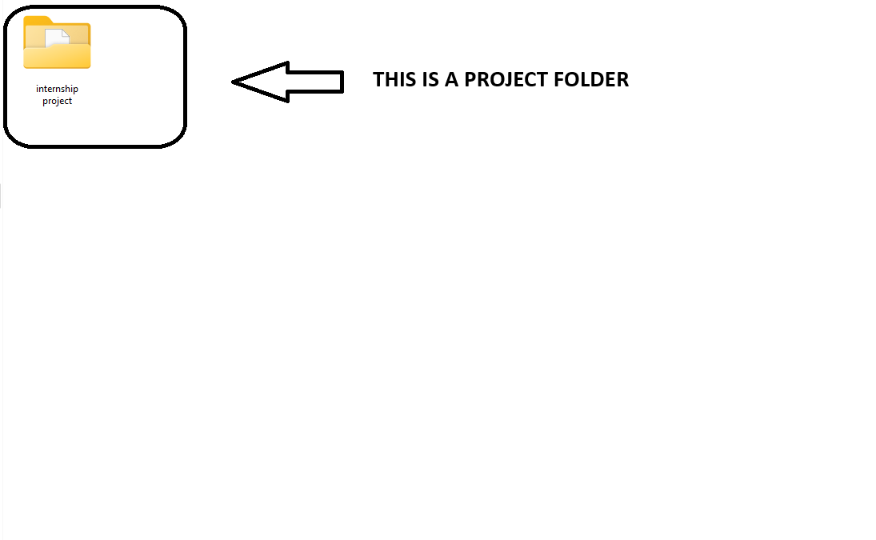

**Step 2: (FIGURE 6.2)**

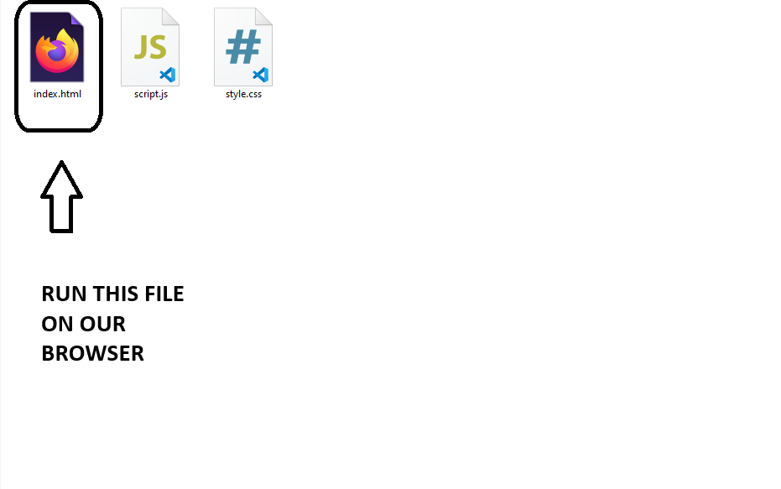

**Step 3: (FIGURE 6.3)**

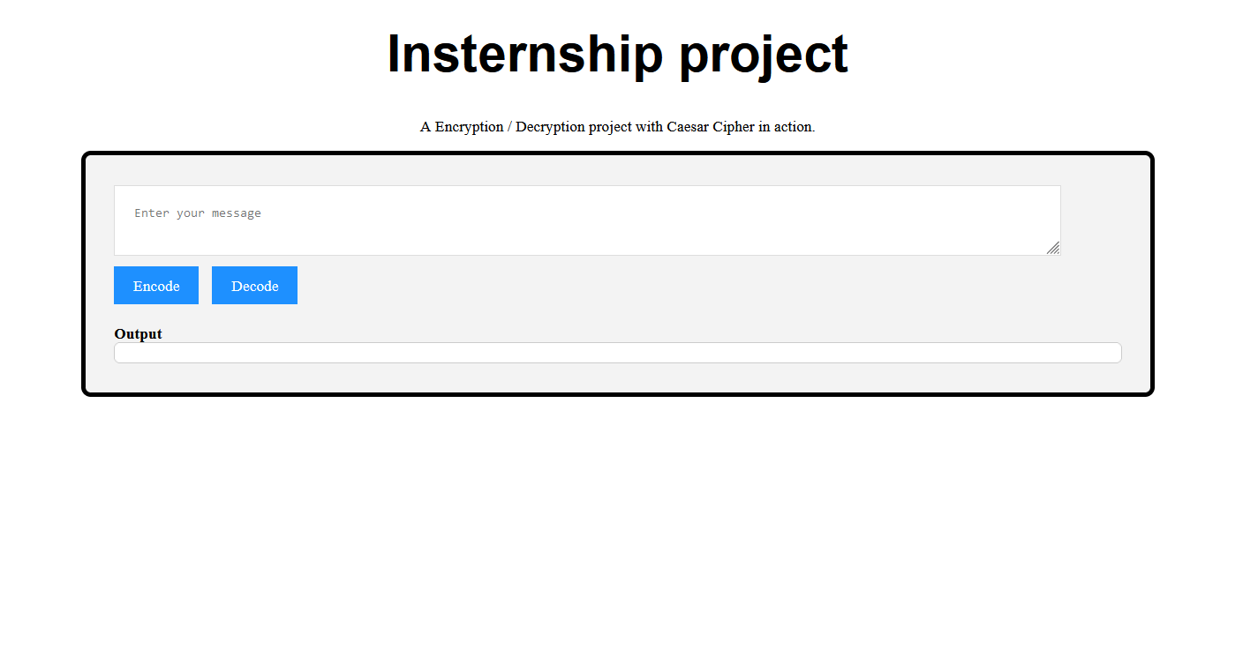

**Step 4 : (FIGURE 6.4)**

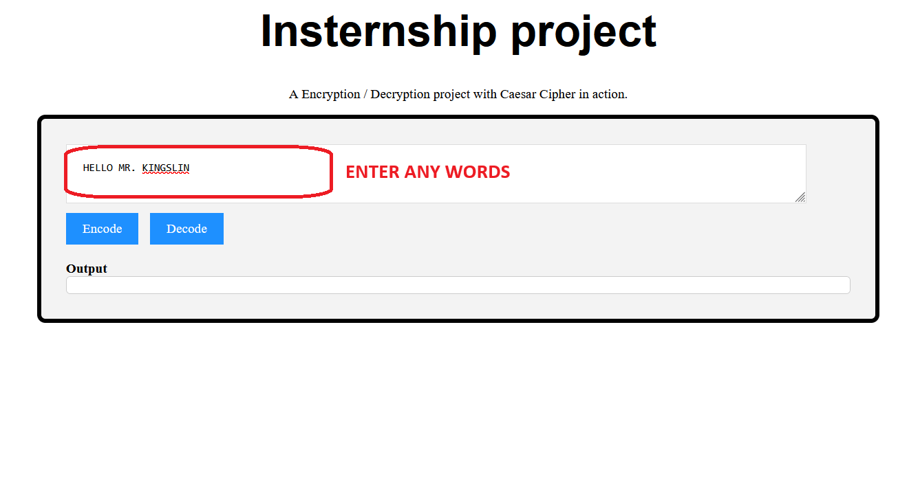

**Step 5 : (FIGURE 6.5)**

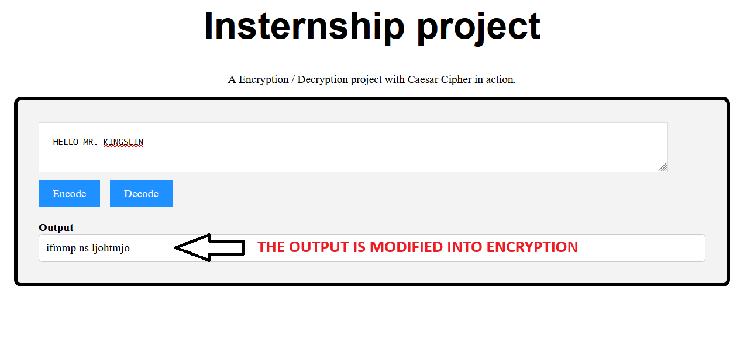

**Step 6 : (FIGURE 6.6)**

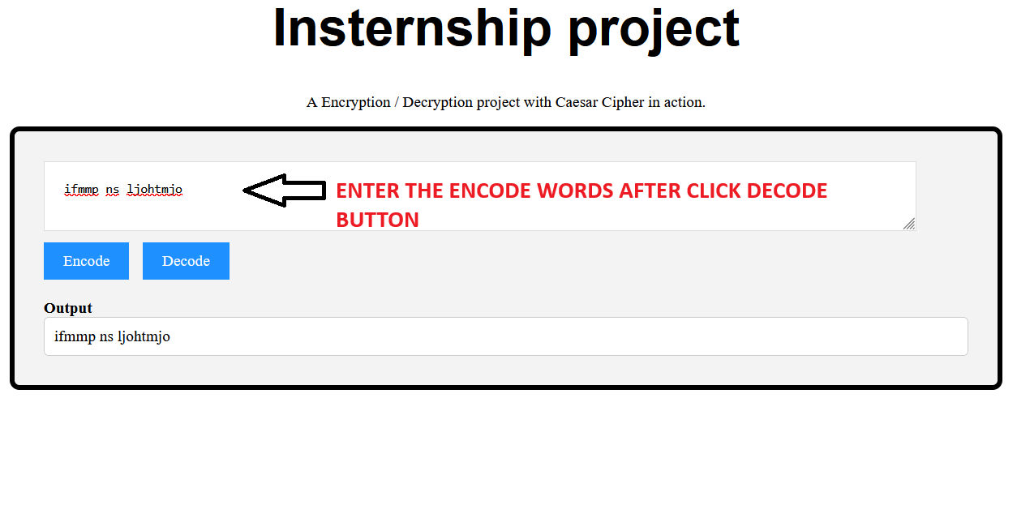

**Step 7 : (FIGURE 6.7)**

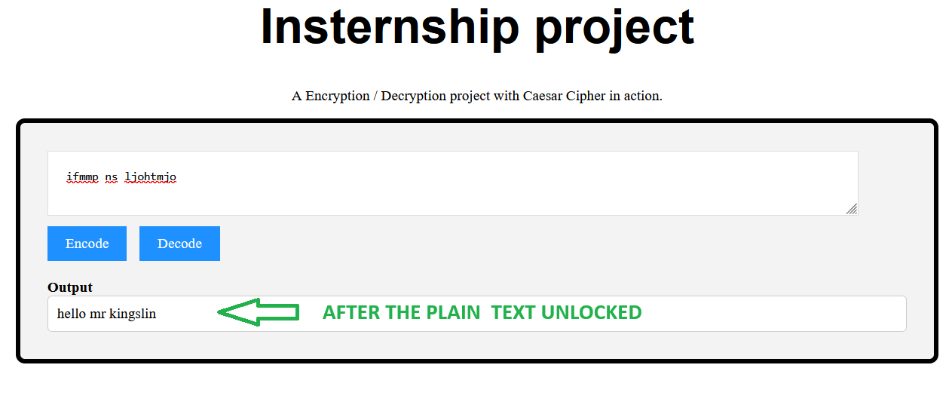

### 6.2. Types of Testing

#### ****6.2.1. UnitTesting****

Testing individual functions such as encrypt(), decrypt(), and caesarCipher() to ensure they perform the desired operations correctly.

#### ****6.2.2. Integration Testing****

Testing how components (HTML, CSS, and JavaScript) work together to ensure the encryption and decryption operations execute seamlessly within the web interface.

#### ****6.2.3. User Interface (UI) Testing:****

Verifying that the user interface elements such as text areas, buttons, and result sections are working as expected and are accessible to users.

#### ****6.2.4. System Testing****

Assessing how efficiently the tool handles large inputs and multiple encryption/decryption requests.

#### ****6.3 Evaluation Criteria****

The evaluation criteria for the **Encryption/Decryption Tool Using Caesar Cipher** focus on several essential aspects that determine the tool's effectiveness and usability. Firstly, **functional correctness** is a primary criterion, ensuring that the encryption and decryption processes work as intended, providing accurate results for different inputs. The **performance** of the tool is also crucial, as it must handle a variety of text sizes without significant delays or crashes. The tool must be optimized for speed and scalability. **Security** is another important consideration, ensuring that the tool does not expose any vulnerabilities or allow for malicious input such as code injections. **Usability** involves testing the user interface for clarity, ease of use, and intuitive design, making sure users can easily understand and interact with the tool. Finally, **compatibility** with various browsers and devices is essential, ensuring that the tool functions consistently across different platforms, including desktops, tablets, and mobile phones. These criteria collectively ensure that the tool meets high standards of reliability, security, and user satisfaction.

### ****CHAPTER 7 - CONCLUSION****

#### The Encryption/Decryption Tool Using Caesar Cipher successfully demonstrates the core principles of cryptography through a simple yet effective web-based application. The tool allows users to easily encrypt and decrypt messages using the Caesar Cipher, with intuitive functionality and an accessible user interface. Through rigorous testing, the tool has proven to perform reliably across various input scenarios, handling edge cases such as special characters and large text inputs without issue. It is optimized for performance, providing fast encryption and decryption operations, and is fully compatible with different web browsers and mobile devices. The application also adheres to key security practices by ensuring that user inputs are properly handled, safeguarding against vulnerabilities. Overall, this project not only serves as a practical tool for cryptographic demonstrations but also provides a solid foundation for further exploration into more complex encryption techniques.

#### ****7.1 Key Achievements****

* **Successful Implementation of Caesar Cipher:**  
  The project successfully implements the Caesar Cipher algorithm, allowing users to encrypt and decrypt messages with ease. This demonstrates the core functionality of a classical encryption method.
* **User-Friendly Interface:**  
  The tool provides a simple, intuitive user interface that enables easy interaction with the encryption and decryption processes, making it accessible for both technical and non-technical users.
* **Cross-Browser and Mobile Compatibility:**  
  The application is fully compatible with major web browsers (Chrome, Firefox, Edge, Safari) and mobile devices, ensuring that users can access and use the tool on a variety of platforms.
* **Handling Edge Cases Effectively:**  
  The tool effectively handles edge cases such as non-alphabetic characters, empty inputs, and large shift values without errors, ensuring robustness in various use scenarios.
* **Security and Input Validation:**  
  The system implements proper input validation to prevent potential security risks, ensuring that the tool operates securely without vulnerabilities.

#### ****7.2 Future Directions****

* **Support for Advanced Cryptographic Algorithms:**  
  While the project currently implements the Caesar Cipher, future iterations could include more advanced encryption algorithms like **AES (Advanced Encryption Standard)**, **RSA**, or **Elliptic Curve Cryptography** to enhance the tool's capabilities and offer stronger security features.
* **User Authentication and Secure Messaging:**  
  Implementing user authentication systems and the ability to securely send encrypted messages over the internet could be a valuable addition. This would involve integrating encryption with secure communication protocols such as **SSL/TLS** for real-world applications.
* **Customizable Encryption Methods:**  
  Allow users to define their own encryption methods, such as shifting by a dynamic key based on user input, or implementing custom cipher algorithms. This would provide flexibility and greater control over the encryption process.
* **Graphical User Interface (GUI) Enhancements:**  
  A more interactive graphical interface could be developed, including features like drag-and-drop for file encryption, progress bars, and real-time previews of the encrypted or decrypted text.
* **Integration with File Encryption:**  
  Future versions could expand the tool to support file encryption and decryption. This would allow users to encrypt not only text but also files such as documents and images, providing a more practical use case for secure data storage and sharing.

### ****CHAPTER 8 - REFERENCES****

1. **Stallings, W.** (2017). *Cryptography and Network Security: Principles and Practice* (7th ed.). Pearson.  
   This book provides in-depth coverage of cryptographic algorithms, including classical ciphers like the Caesar Cipher, and modern encryption techniques such as AES and RSA.
2. **Diffie, W., & Hellman, M. E.** (1976). *New Directions in Cryptography*. IEEE Transactions on Information Theory, 22(6), 644–654.  
   This foundational paper introduced the concept of public-key cryptography and laid the groundwork for modern encryption protocols.
3. **Kaufman, C., Perlman, R., & Speciner, M.** (2002). *Network Security: Private Communication in a Public World* (2nd ed.). Prentice Hall.  
   This text covers a broad range of network security topics, including encryption methods and practical cryptographic systems.